|  |  |  |  |  |  |  |  |  |  |  |  |  |  |  |  |  |  |  |  |  |  |  |  |  |  |
| --- | --- | --- | --- | --- | --- | --- | --- | --- | --- | --- | --- | --- | --- | --- | --- | --- | --- | --- | --- | --- | --- | --- | --- | --- | --- |
| **FORMULIR AKUISISI PROPERTI RUKAN / SOHO – MNC Play** | | | | | | | | | | | | | | | | | | | | | | | | | |
| Nama Properti | | |  | | | | | | | | | | | | | | | | | | | | | | |
| Nama Perusahaan/Pengelola | | |  | | | | | | | | | | | | | | | | | | | | | | |
| Alamat | | | RT. RW. Kec.  Kel. Wil. Kota | | | | | | | | | | | | | | | | | | | | | | |
| Koordinat | | |  | | | | | | | | | | | | | | | | | | | | | | |
| Status Bangunan | | | Clustering/ Under BM Open Area/ Tanpa Pengelola | | | | | | | | | | | | | | | | | | | | | | |
| Existing / Sdh Terbangun | | | | | | | | | | | | | | | Launch DD/MM/YY : | | | | | | | |
| On Progress/ Dlm Pembangunan | | | | | | | | | | | | | | |
| Average Harga Unit | | | Terendah, Rp. Tertinggi, Rp. | | | | | | | | | | | | | | | | | | | | | | |
| Jumlah Cluster atau Blok | | | 1 | | | | 2 | | | 3 | | | 4 | | 5 | | | 6 | | | Keterangan | | | | |
| Jumlah Unit | | |  | | | |  | | |  | | |  | |  | | |  | | |  | | | | |
| Jumlah Lantai | | |  | | | |  | | |  | | |  | |  | | |  | | |  | | | | |
| Jumlah Terhuni | | |  | | | |  | | |  | | |  | |  | | |  | | |  | | | | |
| Tingkat Okupansi | | |  | | | |  | | |  | | |  | |  | | |  | | |  | | | | |
| Infrastruktur Yang Ada | | | Coaxial FTTH ADSL UTP Belum Ada | | | | | | | | | | | | | | | | | | | | | | |
| Main Hole Ready | | | Di Unit YA TIDAK | Di Koridor YA TIDAK | | | | | | | | | | | | | | | | | | | | | | |
| Metode Pembangunan Infrastruktur | | | KU – Kabel Udara *(Pasang Tiang / Clamp Wall / Ceilling)* | | | | | | | | | | | | | | | | | | | | | | |
| UG – Under Ground *(Bawah Tanah / Suwer – Saluran Air)* | | | | | | | | | | | | | | | | | | | | | | |
| Mixed KU *(Kabel Udara)* – UG *(Under Ground)* | | | | | | | | | | | | | | | | | | | | | | |
| Pembangunan Infrastruktur s/d. | | | Control Room Shaft (FAT) Unit (TB) | | | | | | | | | | | | | | | | | | | | | | |
| Internet Service | | | Dedicated Broadband | | | | | | | | | | | | | | | | | | | | | | |
| Layanan Yang Disediakan MNC | | | Internet IPTV Telephony* | | | | | | | | | | | | | | | | | | | | | | |
| Mayoritas Jenis Usaha *(Pilih dan isi dengan angka sesuai kondisi dilapangan)* | | | | | | | | | | | | | | | | | | | | | | | | | |
| Distributor ( ), Resto/Cafe ( ), Bank ( ), Mini Market /Apotek ( ), Tour & Travel ( )  Lembaga Pendidikan ( ), Konsultan Non legal & Legal ( ), Modern Market /Hyper Store ( ) ATPM/Principle ( ), Expedisi ( ), Agency ( ), Showroom (Mobil /Motor), Bengkel ( ) Pergudangan ( ), Others : | | | | | | | | | | | | | | | | | | | | | | | | | |
| Pengelola berkenan untuk membantu penjualan? Ya Tidak | | | | | | | | | | | | | | | | | | | | | | | | | |
| Berapa harga rata-rata berlangganan internet per-bulan? Rp. | | | | | | | | | | | | | | | | | | | | | | | | | |
| Presentase Operasional Rukan / SOHO Weekday _________% Weekend, Sabtu _________% Minggu _________% | | | | | | | | | | | | | | | | | | | | | | | | | |
| **Provider Existing** | | | | **Berikan tanda cek list** | | | | | | | **Eksklusif** | | | | | **Durasi Kerjasama s/d. Bln/Thn** | | | | | | **Skema Kerjasama** | | | |
| **Inet** | | **TV** | | | **Telp.** | | **Y** | | | **N** | | **Rev.Share (%)** | | **Sewa Lahan**  **(Rp.)** | |
| 1. |  | | |  | |  | | |  | |  | | |  | |  | | | | | |  | |  | |
| 2. |  | | |  | |  | | |  | |  | | |  | |  | | | | | |  | |  | |
| 3. |  | | |  | |  | | |  | |  | | |  | |  | | | | | |  | |  | |
| 4. |  | | |  | |  | | |  | |  | | |  | |  | | | | | |  | |  | |
| 5. |  | | |  | |  | | |  | |  | | |  | |  | | | | | |  | |  | |
| **Skema Kerjasama Dengan MNC Play** | | | | | | | | | | | | | | | | | | | | | | | | | |
| Status Kerjasama/Periode | | | | Exclusive Non Exclusive Thn | | | | | | | | | | | | | | | | | | | | | |
| **Aktifitas Sales & Marketing Tools** | | | | | | | | | | | | | | | | | | | | | | | | | |
| Penempatan/Pemasangan/  penyebaran Marketing Tools | | **Mading** | | | | | | **Area Parkir** | | | | **Pintu Parkir / Pos Security** | | | | | **Kantor Pengelola** | | | **Pubik Area** | | | **Diseluruh Area Cluster** | | **Others** |
| Aktifitas Sales Probing | |  | | | | | |  | | | |  | | | | |  | | |  | | |  | |  |
| Pop Up Table (*terlampir*) | |  | | | | | |  | | | |  | | | | |  | | |  | | |  | |  |
| Penempatan Spanduk (*terlampir*) | |  | | | | | |  | | | |  | | | | |  | | |  | | |  | |  |
| Penempatan Poster (*terlampir*) | |  | | | | | |  | | | |  | | | | |  | | |  | | |  | |  |
| Experience Car (*terlampir*) | |  | | | | | |  | | | |  | | | | |  | | |  | | |  | |  |
| X/Roll Up Banner (*terlampir*) | |  | | | | | |  | | | |  | | | | |  | | |  | | |  | |  |
| Acrilic Box /Brosur (*terlampir*) | |  | | | | | |  | | | |  | | | | |  | | |  | | |  | |  |
| Catatan; | | | | | | | | | | | | | | | | | | | | | | | | | |
| Saya yang bertandatangan menyatakan bahwa informasi ini adalah benar adanya, untuk kebutuhan follow up kerjasama yang cepat secara detail dan akurat. | | | | | MNC Play  (..................................................)  Jabatan: | | | | | | | | | | | | | | Pihak Mitra  Tgl.  (..................................................)  Jabatan:  No.Telp.  No.HP. | | | | | | |

|  |  |
| --- | --- |
| Catatan dan Rekomendasi Sales Kadept./ Kadiv.  Rekomendasi : REJECT DROP APPROVE | Jakarta, _____________________  (..................................................)  Jabatan: |

* Optional | Catatan: Beri tanda Cek (√) pada kolom pilihan dan coret yang tidak perlu

REJECT : Projek tidak direkomendasikan secara permanen

DROP : Projek tidak direkomendasikan namun dapat di follow up kembali

APPROVE : Projek disetujui dan dapat dilanjutkan

**POP UP TABLE**

*Ukuran 184 cm x 90 cm*

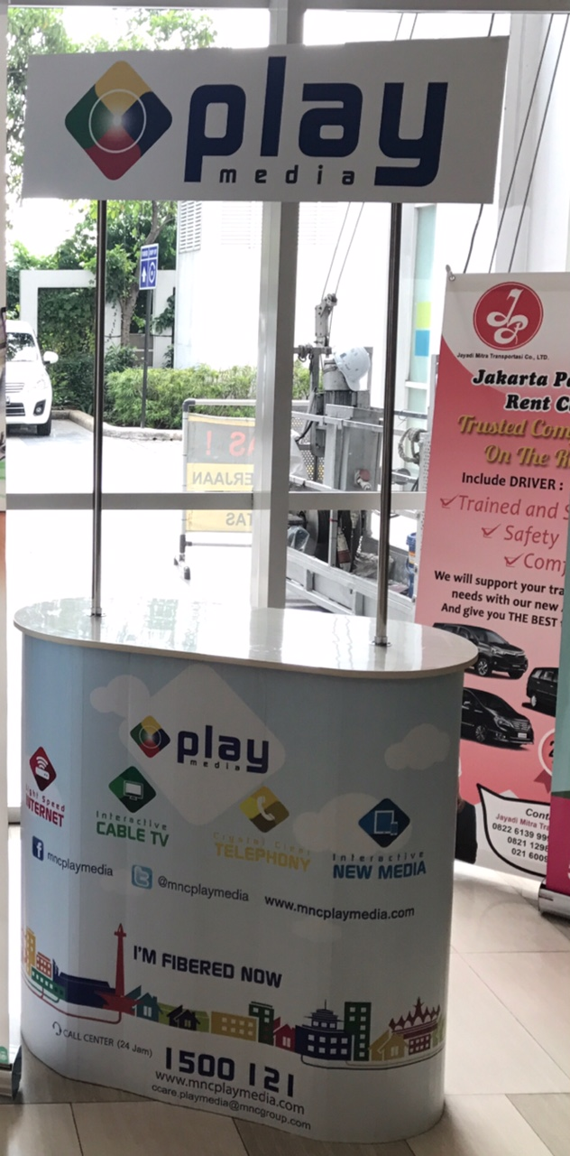

**POSTER**

*Ukuran 118,9 cm x 84,1 cm*

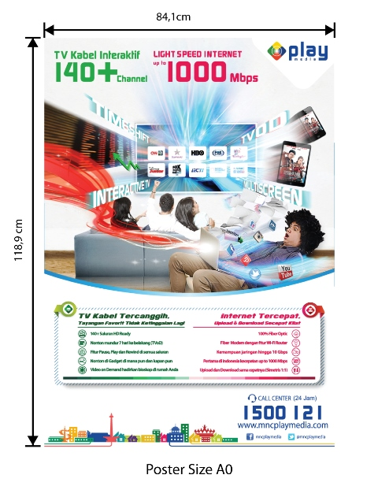

**ACRILIC BOX /Brosur**

*Ukuran 20 cm x 30 cm x 5 cm*

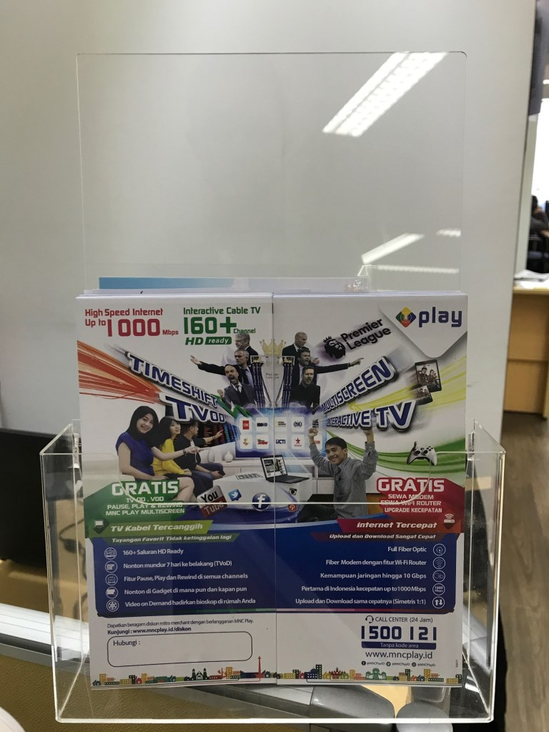

**X/ROLL UP BANNER**

*Ukuran 200 cm x 80 cm*

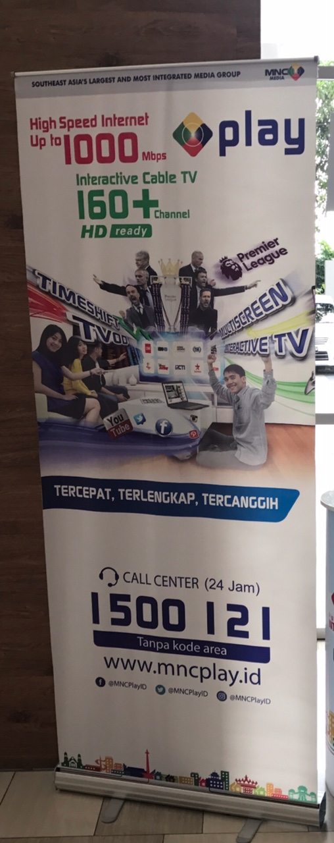

**SPANDUK**

*(ukuran 2 x 4 m / disesuaikan)*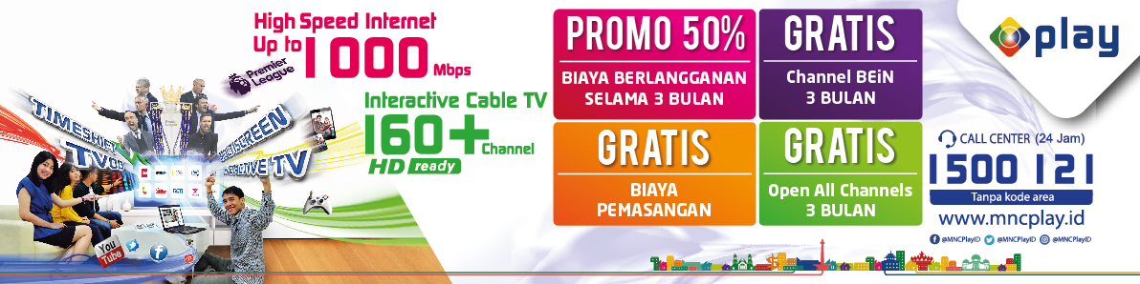

*Catatan:*

*Design, content atau redaksi serta ukuran pada material marketing tools diatas adalah merupakan ilustrasi semata. Design, content atau redaksi serta ukuran yang akan digunakan sebagai materi promosi akan mengikuti atau disesuaikan dengan kondisi yang ada.*